1. TITLE OF THE LESSON  Responding to Crisis | 2. CURRICULUM AREA & GRADE LEVEL  11th Grade U.S. History/ Spanish
3A. STUDENT INFORMATION: English Language Learners  Stephanie Aceituno / Julio  1.) Readiness Level  ELD level 6 early advanced/ ELD 3 Early intermediate  2.) Learning Profile  Non-linguistic aids guided instruction with implementation on reading and writing strategies  3.) Interest  arts and dance/ sports (soccer) | 3B. STUDENT INFORMATION: Students w/ Special Needs  Dan  1.) Readiness Level- Dan has difficulty with writing, especially with spelling. Dan struggles to put his thoughts down on paper.  2.) Learning Profile- Dan needs to see the material and work hands on. He learns best with repetition. David is easily side-tracked and needs to be reeled back into the activities.  3.) Interest- Dan enjoys hanging out. He likes to participate in class. Dan likes to participate and share his knowledge.
4. RATIONALE
A. Essential Questions
How to respond to a crisis? What actions can you take to receive help after going through a crisis?
B. Content Objective
Students will analyze modern crisis of 9/11, Hurricane Sandy, and Sandy Hook and will participate in classroom discussion.
Language Objective
Students will complete “Crisis Activity Worksheet” and will write their personal responses in their journals.

7. LEARNING GOAL(S) - OBJECTIVE(S)  After students will be able to understand the severity of modern day crisis and will be better informed on how to respond to crisis. In addition, students will be able to write in their journals of their personal reactions to each crisis after a classroom discussion and “Crisis Activity Worksheet”. | B. Formative-Progress Monitoring  Teacher will assess the students through informal monitoring of the students during classroom discussion. The formal assessment will be the completion of “Crisis Activity Worksheet” and their written responses in their journals.
9A. EXPLANATION OF DIFFERENTIATION FOR  ENGLISH LANGUAGE LEARNERS  - Process/Based on Readiness, Learning Profile or Interest  Students will be given a variety of different sources of visual aids to see the severity of each crisis. In addition, students will partake in the “Crisis Activity Worksheet” and also their personal thoughts and reflections will be recorded in their journal entry. | 9B. EXPLANATION OF DIFFERENTIATION FOR  STUDENTS WITH SPECIAL NEEDS  - Process/Based on Readiness, Learning Profile or Interest- Dan will be given the Crisis worksheet to follow along and help him keep on track with the activity. The Crisis worksheet will have pictures to help Dan make connections between the videos and the discussed effects.
10. INSTRUCTIONAL STRATEGIES (Describe what the teacher does. Include differentiation strategies.)  A. Anticipatory Set/Into  1. Co-teachers will stand at the door and to greet the students and ask them, “To tell them something good.”  2. Co-teachers will introduce the combination of the two classes through the combined lesson topic of “Responding to Crisis”.  Total time (5 min)  B. Instruction/Through  3. Teacher will introduce the first modern day crisis, 9/11, and will give a brief description of the event.  (5 min)  4. Co-teacher will read a short excerpt of a newspaper covering the event.  5. Co-teacher will pass out the “Crisis Activity Worksheet”  -(Activity worksheet will cover all crisis and will be used throughout the entire class)  6. Teacher will put on the video clip of 9/11.  7. Teacher will start classroom discussion on the severity of the 9/11 crisis.  (30 min total on 9/11)  8. Co-teacher will introduce Hurricane Sandy by giving a brief description of the event.  9. Teacher will play the video of Hurricane Sandy.  10. Co-Teacher will lead discussion on Hurricane Sandy.  (30 min total on Hurricane Sandy)  11. Teacher will introduce Sandy Hook crisis.  12. Co-teacher will play video of Sandy Hook Crisis.  13. Supportive approach of co-teaching on leading discussion of Sandy Hook.  14. Teacher will discuss possible crisis that may occur in our community or as certain individuals.  (30 min total on Sandy Hook)  15. Teacher instructs students to start their journal entry of “How did the crisis affect you as an individual? How would you respond to these crisis?”  1.45 hrs.  C. Guided Practice/Through  Students will be instructed to participate in classroom discussion on each of the crisis events and will also gain knowledge from newspaper clips, video instruction and activity worksheet.  D. Independent Practice/Through  Students will be instructed to complete their journal entries on “How did the crisis affect you as an individual? How would you respond to these crisis?”  E. Closure  Teacher will sum up todays lesson by explaining the correlation of the different crisis we discussed and linking it to how students can respond to crisis in their communities.  F. Beyond  Encourage students to spread their insight to the rest of their school and community. | 11. STUDENT ACTIVITIES (Describe what the students does. Include differentiation activities.)  A. Anticipatory Set/Into  1. Students will greet the co-teachers at the door and together participates in saying something good.  2. Students will listen to the introduction of the unit topic of “Responding to Crisis”  Total time (5 min)  B. Instruction/Through  3. Students will listen to the introduction of 9/11.  4. Students will listen to the excerpt of the newspaper article.  5. Students complete the “Crisis Activity Worksheet” throughout the period.  6. Students will watch the video of 9/11  7. Students will participate in the classroom discussion on 9/11.  (30 min total on 9/11)  8. Students will listen to the introduction of Hurricane Sandy.  9. Students will watch the video of Hurricane Sandy.  10. Students will participate in classroom discussion of Hurricane Sandy.  (30 min total on Hurricane Sandy)  11. Students will listen to introduction of Sandy Hook Crisis.  12. Students will watch the video of Sandy Hook.  13. Students will participate in classroom discussion of Sandy Hook.  14. Students will participate in discussion of crisis in their community.  (30 min total on Sandy Hook)  15. Students will write in their journal entry and answering the questions listed by the teacher.  1.45 hrs  C. Guided Practice/Through  Students will be critically think in participating in classroom discussion on each of the crisis events and will also gain knowledge from newspaper clips, video instruction and activity worksheet.  D. Independent Practice/Through  Students will be complete their journal entries on “How did the crisis affect you as an individual? How would you respond to these crisis?”  E. Closure  Student will listen to the teacher summing up todays lesson and will ask any questions that they may have.  F. Beyond  Students encouraged to spread their insight to the rest of their school and community.
12. RESOURCES Video display, “Crisis Activity Worksheet”, newspaper from the crisis

5. CONTENT STANDARD(S)
CONTENT
3.0 Students acquire information, recognize distinctive viewpoints, and further their knowledge of other disciplines.
3.1 Students address concrete and factual topics related to the immediate and external environment, including:
j. Significant historical events

Reflection:
The strength of this lesson is that it provides a multiple visuals for the ELL learners and the Special Needs. Students are going to be able to contrast what they have learned in their history and Spanish classes. In addition, the students are going to be able to discuss with each other prior to having the classroom discussion. This will help the students not only learn from each other but the students who are too shy to speak in front of the whole class. The information provided in the lesson should hit home to the students as it has happened in their lifetime. By the end of the week unit, students will be better equipped to handle crisis and in responding to crisis. It is our goal that by providing multiple visuals students will be able prepared once a crisis hits and they will know how to act accordingly.
Being that Vista High School is on the block schedule of alternating classes for two hour blocks this unit will take on week to implement. This lesson plan is at the end of the one-week unit and will take the entire 2-hour block on the last day. Co-teachers have taught their lesson plans in the subject area to provide background information prior to starting this lesson. Both the Spanish and history elements will infuse history and cultural background prior to starting the last part in which we make it more relevant to them. This unit is designed to show a variety of different sources to show how to respond to crisis. This lesson plan entails visual elements and classroom discussions to meet out students needs. We will watch a video clip or look at a newspaper to keep our students interested. We have differentiated for all students as we have them grouped in heterogeneous groups prior to starting the classroom discussion. The worksheet contains more visuals to appeal to the visual learners. Co-teachers will walk around and ask questions to spark more insight to all of the groups. By having this lesson plan at end of the unit students will be able to see the severity of each crisis and leave them with a lasting memory. It is consistent in linking what information that they have gained so far prior to doing this lesson, and really drives home the notion of crisis during their lifetime. If students have a hard time grappling with one of the crisis, teachers will be available to go over more in detail after class is out. Teachers will bring in more sources to help foster learning and will be available for discussion when needed.
Teacher Script:
- Pass out worksheet at beginning of the class. (2 min)
- Give brief overview of the lesson (5 min)
- Read the newspaper article of 9/11(5-10 min)
- Play 9/11 video (10 min)
- Have students work in pairs to prepare for discussion (10 min)
- Classroom discussion (10 min)
- Give brief overview of Hurricane Sandy (2 min)
- Play video of Hurricane Sandy (10 min)
- Have students work in pairs to prepare for discussion (10 min)
- Classroom discussion (10 min)
- Give brief overview of Sandy Hook (2 min)
- Play video of Sandy Hook (10 min)
- Have students work in pairs to prepare for discussion (10 min)
- Classroom discussion (10 min)

Crisis Activity Worksheet

Event #1: 9/11
1) Background Information:
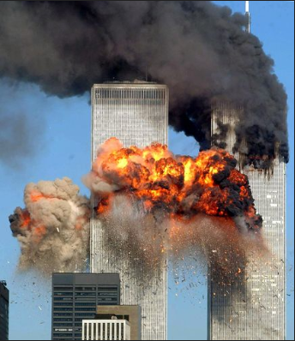
____________________________________________________________________________
_____________________________________________________________________________________________________________________

2) What were the effects of the devastation?
_________________________________________________________________________________________________________________________________________________________

Event #2: Sandy Hook Elementary
1) Background Information
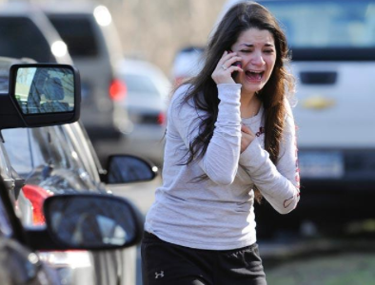
_________________________________________________________________________________________________________________________________________________________________________________________

2) What was the effect of the devastation?
_________________________________________________________________________________________________________________________________________________________

Event #3: Hurricane Sandy
1) Background Information
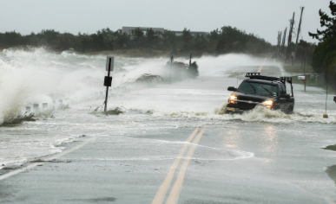
_______________________________________________________________________________________________________________________________________________________________________________

2) What was the effect of the devastation?
_________________________________________________________________________________________________________________________________________________________

Reflection: (What did you learn, How did it make you feel, What is the lasting impact…)
__________________________________________________________________________________________________________________________________________________________________________________________________________________________________________________________________________________________________________________

