Crisis Activity Worksheet

Event #1: 9/11
1) Background Information:
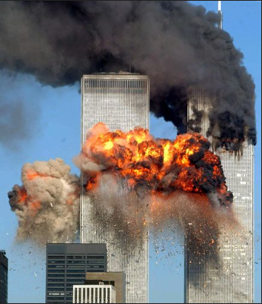
____________________________________________________________________________
_____________________________________________________________________________________________________________________

2) What were the effects of the devastation?
_________________________________________________________________________________________________________________________________________________________

Event #2: Sandy Hook Elementary
1) Background Information
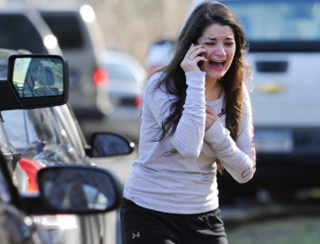
_________________________________________________________________________________________________________________________________________________________________________________________

2) What was the effect of the devastation?
_________________________________________________________________________________________________________________________________________________________

Event #3: Hurricane Sandy
1) Background Information
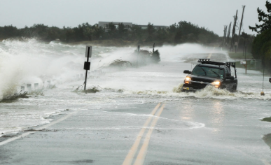
_______________________________________________________________________________________________________________________________________________________________________________

2) What was the effect of the devastation?
_________________________________________________________________________________________________________________________________________________________

Reflection: (What did you learn, How did it make you feel, What is the lasting impact…)
__________________________________________________________________________________________________________________________________________________________________________________________________________________________________________________________________________________________________________________

